Stability

Tf-idf:

Decision tree:

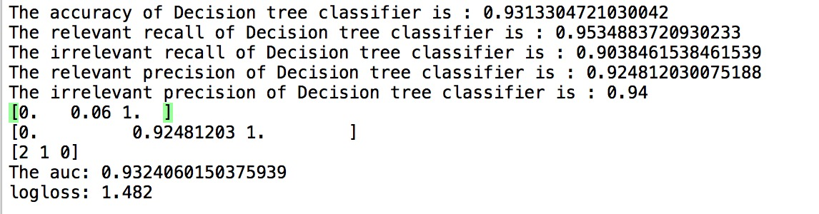

KNN-7



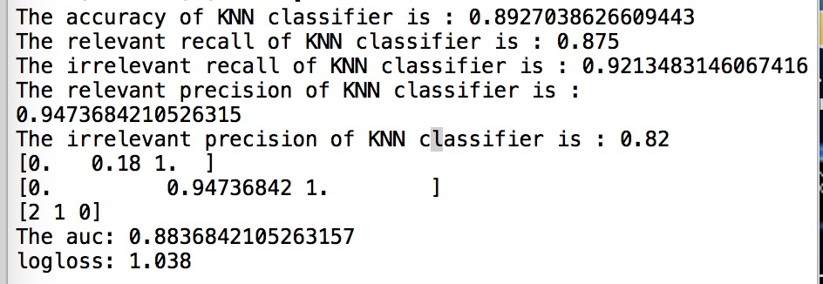

Naïve Bayes:

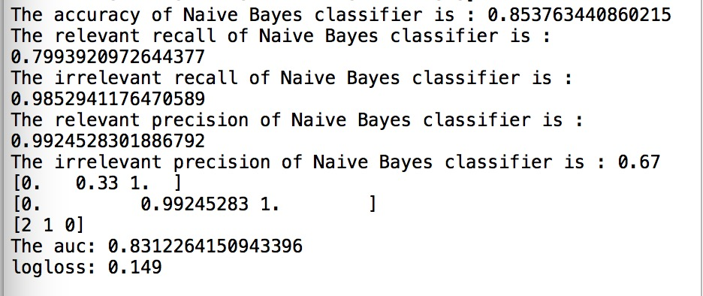



Logistical:



C=10



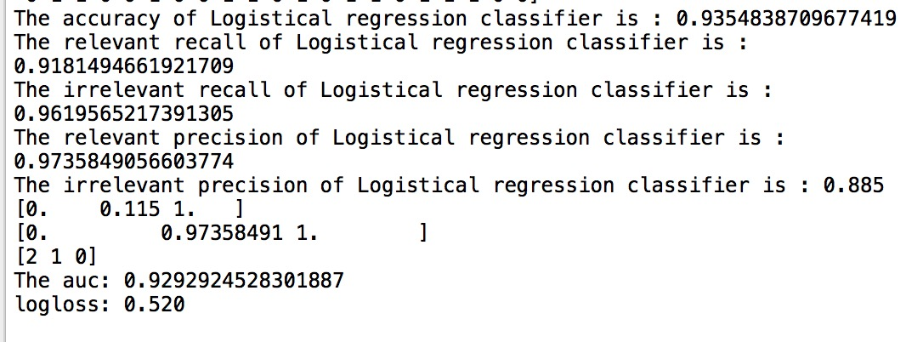

SVM:

Sigmoid:

C=1





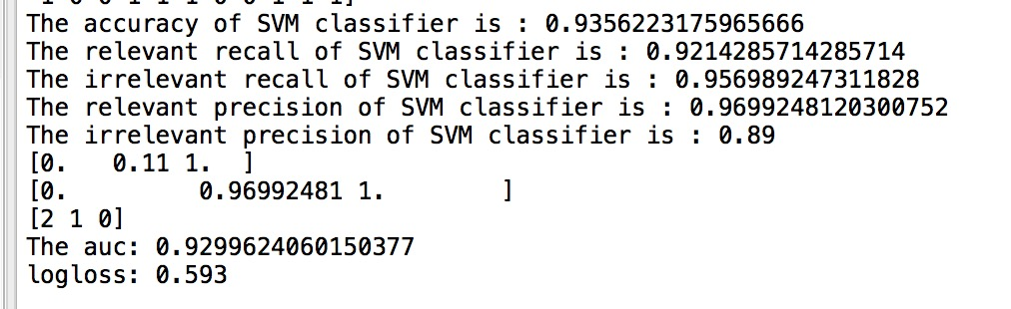

Rbf:



C=10

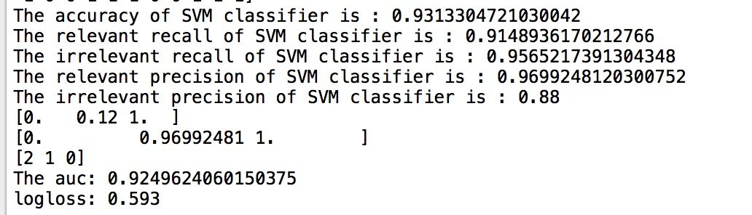

Poly:



C=10

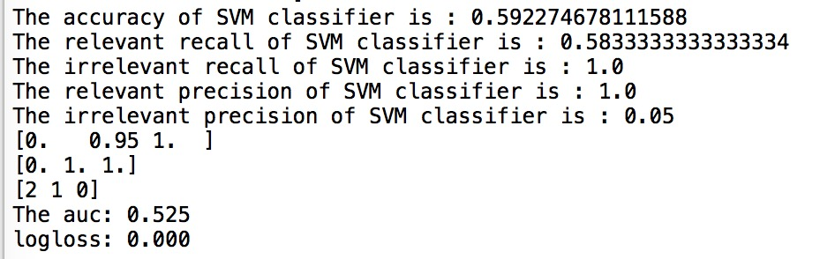

Linear:



C=1



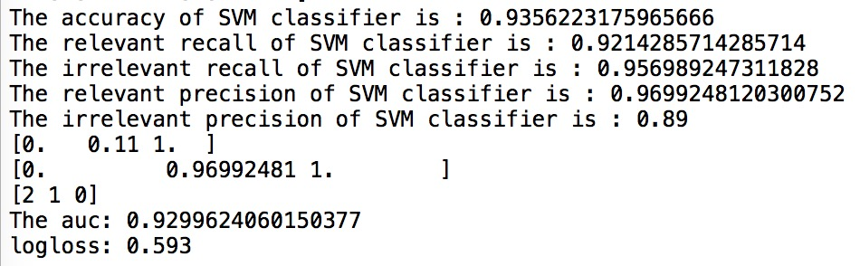

Word2vec:

KNN-4:

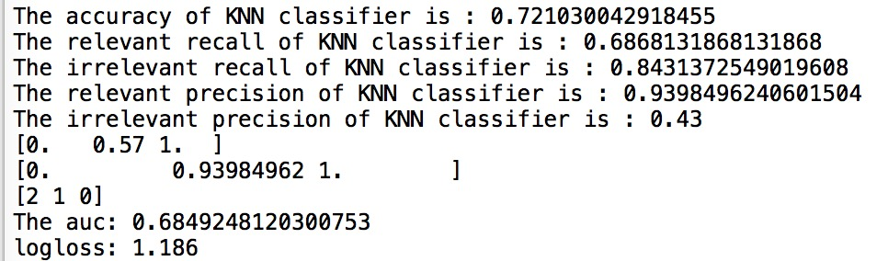

Decision tree:

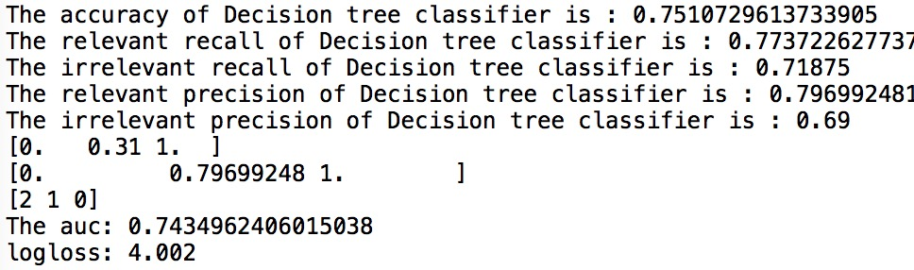

Naïve Bayes:

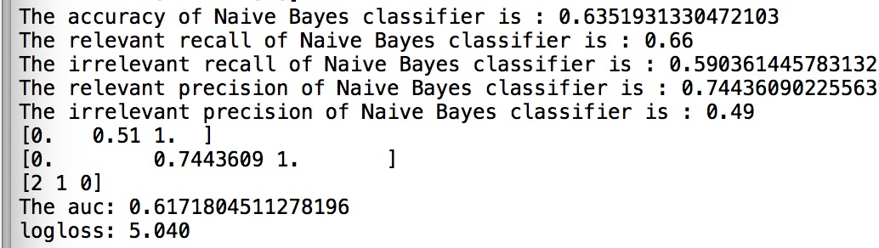

Logisitcial:



C=10000

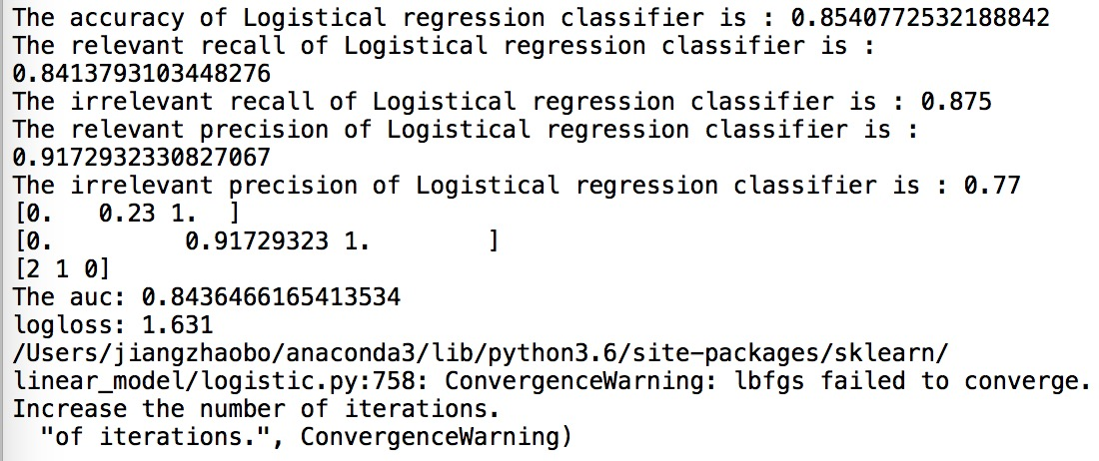

Svm:

Rbf



C=10000

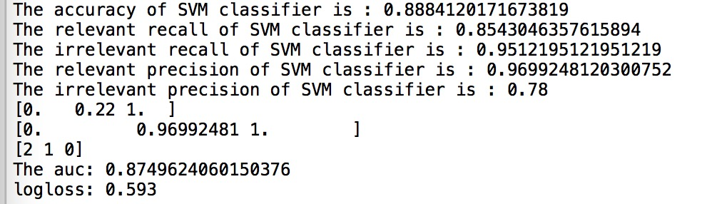

Linear:



C=10000



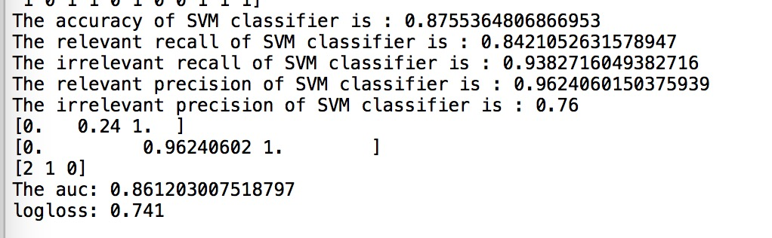

Sigmoid:

C=1000

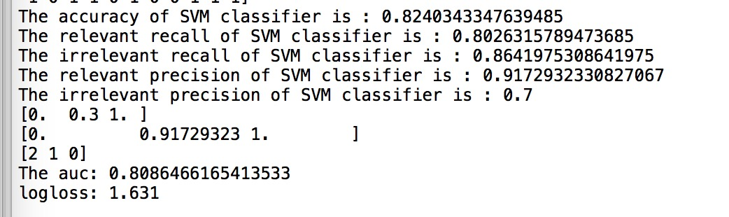

Poly:

